**IMAGE RESTORATION AND WIENER FILTER**

We saw other enhancing techniques before

* LPF or Gaussian filtering to remove Gaussian noise
* Median filtering to remove impulsive noise
* Unsharp masking to enhance details

But these techniques are subjective but image restoration is objective in nature because the kind of degradation is known.

Basic model for degradation:

Flow for a degraded image:

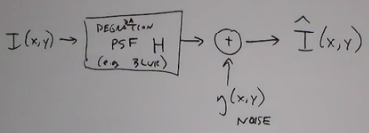

Flow for restored image:

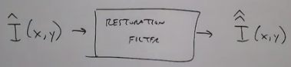

So mathematically the least squares error between  and  is as minimal as possible. A restoration filter must be designed to keep it minimal.

In the spatial and frequency domain respectively:

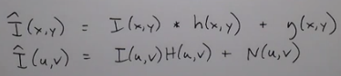

Easier case: when there is no degradation, (i.e. H = Identity) and noise is present only. Noise is typically described by a PMF:



Noise may be due to:

* Environmental conditions (light level, temperature changes)
* Non-ideal sensor elements in hardware
* Corruption during transmission/compression

Common noise pdfs:

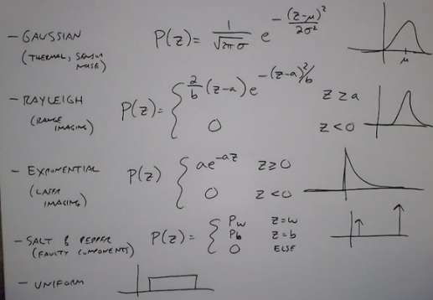

The noises mentioned above are all independent for each pixel.

But it is also possible to have correlated noise. (periodic noise)

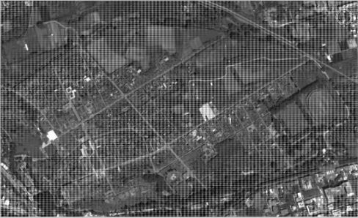

Such image noise would manifest itself more clearly in frequency domain.

Periodic noise manifests as an unusual peaks in the FFT. These can be removed using a notch filter. Here we filter at a certain bandwidth, not affecting any frequency above or below the bandwidth.

How to determine what kind of noise is present in an image?

* One way is to find a region in an image that should be flat (constant intensity) and visualize the image histogram for that region. Fit a Gaussian function for that. Get the mean and variance from that. Since the distribution actually looks like a Gaussian, the noise is Gaussian in nature.